London, 12 November 2017

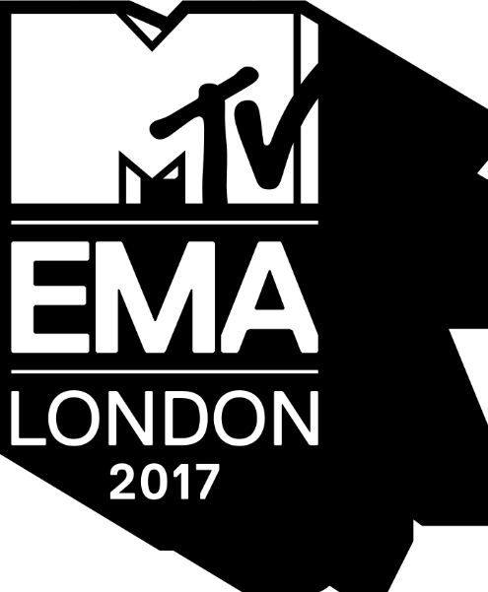

WORLDS COLLIDE AT 2017 MTV EMAS FOR THE YEAR’S BIGGEST NIGHT
IN GLOBAL MUSIC

EMINEM MAKES GRAND RETURN TO THE STAGE WITH WORLD PERFORMANCE DEBUT
OF HIS NEW SINGLE “WALK ON WATER”

GLOBAL ICON HONOREES U2 ROCK LONDON’S ICONIC TRAFALGAR SQUARE

Download photos and videos at press.mtvema.com

The 2017 MTV EMAs opened with Best Hip Hop winner Eminem doing a thrilling orchestra-backed performance, along with guest artist Skylar Grey, of his newly dropped track “Walk on Water,” taking the mic in a London pub before joining the EMA stage at The SSE Arena, Wembley.

Following, the audience saw global pop star and hometown hostess Rita Ora run through London’s streets to get to the show, with UK radio crew Kurupt FM of British sitcom “People Just Do Nothing” and a cameo from the Mayor of London himself.

Proving they’re the biggest band in the world, U2 performed “Get Out Of Your Own Way” from London’s historic Trafalgar Square and was honored with the night’s prestigious milestone award, Global Icon.

Best Pop winner Camila Cabello’s captivating and elaborate musical production featured a hugely choreographed routine that moved through three scenes and incorporated soaring overhead shots, ending in a Havana-style swimming pool.

Liam Payne got hearts racing with a steamy performance of “Strip That Down” featuring dancers in streetwear moving across an LED disco floor, while perched on hydraulics set to a spectacular LED light show.

Bold entrances were the theme for the night with Travis Scott flying in on the back of an animatronic bird over the audience for his performance of “Butterfly Effect,” while Stormzy arrived in a police car for his smash grime track “Big For Your Boots.”

The Killers performed “The Man” via a stripped down, stirring classic rock performance.

Shawn Mendes was crowned Best Artist and rocked his Best Song-winning track “There’s Nothing Holding Me Back” in an ever-evolving light box.

Host Rita Ora’s performance featured more than 50 dancers in an over-the-top medley of songs from her new album, “Your Song” and “Anywhere.”

Other artists delivering a mix of fan favorite tracks included Demi Lovato with her performance of “Sorry Not Sorry” and “Tell Me You Love Me,” and Kesha’s moving rendition of “Learn to Let Go.”

David Guetta closed the show with an electrifying performance of his new single “Dirty, Sexy, Money” with guests French Montana, and Charli XCX.

Later, Rita Ora was presented with the first-ever “MTV EMA Power of Music Award” honoring the charitable efforts on behalf of all the artists who responded to Grenfell.

Additionally, MTV recognized artists from around the globe with Worldwide Act awards and Best Local Act awards for multiple regions including Spain, The Netherlands, Japan and Nigeria. Worldwide Act recognizes those artists who have evolved their footprint and established their names beyond their local borders in 2017. They are selected from all the regional EMA award nominees by an international panel of MTV music executives.

At the close of show, Ora announced that the 2018 MTV EMAs would be held in Bilbao, Spain.

See complete list of winners and performances below.
FULL LIST OF 2017 MTV EMA WINNERS
BEST SONG
Shawn Mendes - There’s Nothing Holdin’ Me Back

BEST ARTIST
Shawn Mendes

BEST LOOK
ZAYN

BEST NEW
Dua Lipa

BEST POP
Camila Cabello

BEST VIDEO
Kendrick Lamar - HUMBLE.

BEST LIVE
Ed Sheeran

BEST ELECTRONIC
David Guetta

BEST ROCK
Coldplay

BEST HIP HOP
Eminem

BEST ALTERNATIVE
Thirty Seconds To Mars

BIGGEST FANS
Shawn Mendes

BEST PUSH
Hailee Steinfeld

BEST WORLD STAGE
The Chainsmokers – Live from Isle of MTV Malta 2017
WORLDWIDE ACT WINNERS
Lil’ Kleine - The Netherlands
C. Tangana – Spain
BABYMETAL – Japan
ALMA – Finland
DaVido – Nigeria
Stormzy - UK & Ireland
Lali - Argentina

FULL PERFORMANCE LIST
Rita Ora – “Your Song,” “Anywhere”
Demi Lovato – “Sorry Not Sorry,” “Tell Me You Love Me”
Kesha – “Learn to Let Go”
Shawn Mendes – “There's Nothing Holdin’ Me Back”
The Killers – “The Man”
Clean Bandit – “Miss You” ft. Julia Michaels, “Symphony” ft. Zara Larsson, “Rockabye” ft. Anne-Marie
Stormzy – “Big For Your Boots”
Camila Cabello - “Havana”
U2 – “Get Out of Your Own Way,” remote from Trafalgar Square
Eminem – “Walk on Water” ft. Skylar Grey
French Montana – “Unforgettable” ft. Swae Lee
Travis Scott – “Butterfly Effect”
David Guetta ft. Charli XCX, French Montana –“Dirty Sexy Money”
Liam Payne – “Strip That Down”

For additional artwork, press assets and show information please visit press.mtvema.com.

###
About the 2017 MTV EMAS
The 2017 MTV EMAs, in partnership with Daddy's Home 2, hmv and Aussie Hair, will broadcast LIVE across the globe on Sunday, 12th November at 8:00PM GMT** from The SSE Arena, Wembley in London, England in partnership with #LondonIsOpen. One of the biggest global music events of the year that celebrates the hottest artists from around the world, the MTV EMAs bring music fans a unique, multi-platform experience across MTV’s global network of more than 60 channels and over 300 digital media properties and platforms. Follow @MTVEMA on Facebook, Twitter, Snapchat (@MTVEMA) and Instagram, and join the conversation with #MTVEMA. Bruce Gillmer and Richard Godfrey are Executive Producers for the 2017 MTV EMAs. Debbie Phillips and Chloe Mason are Producers. Hamish Hamilton is Director. For MTV EMA news, updates and press materials please visit press.mtvema.com.
**Check local listings.

About #LondonIsOpen
#LondonIsOpen is a major campaign – launched by the Mayor, Sadiq Khan – to show that London is united and open for business, and to the world, following the EU referendum. It shows the world that London remains entrepreneurial, international and full of creativity and possibility. It reassures the more than one million foreign nationals who live in London that they will always be welcome, and that any form of discrimination will not be tolerated

Press Contacts
Gayle Gaviola, gayle.gaviola@viacom.com
Jessica Nicola, Jessica.nicola@viacommix.com

