UNDER EMBARGO UNTIL OCT. 20, 2021 AT 12PM CEST/11AM BST/6AM ET
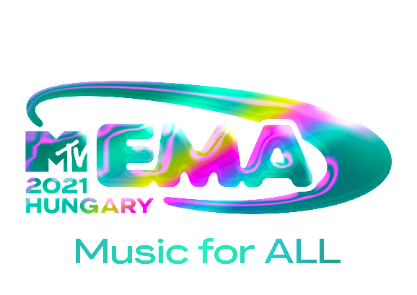
JUSTIN BIEBER LEADS “2021 MTV EMAs” NOMINATIONS FOLLOWED BY DOJA CAT, LIL NAS X, ED SHEERAN, OLIVIA RODRIGO AND THE KID LAROI FOR 28TH EDITION AIRING LIVE GLOBALLY ON NOVEMBER 14th FROM BUDAPEST, HUNGARY

VOTING NOW OPEN AT MTVEMA.COM

DOWNLOAD ASSETS HERE
SOCIAL TAGS: #MTVEMA @MTVEMA @VIACOM_INTL

NEW YORK/BUDAPEST—OCT. 20, 2021—MTV today announced nominations for the “2021 MTV EMAs,” with frontrunner Justin Bieber securing eight nominations. Bieber’s nods include “Best Artist,” “Best Pop,” two “Best Song” noms for his global hits “Peaches” featuring Daniel Caesar and Giveon and “STAY” with The Kid LAROI, “Best Video” for “Peaches,” “Best Collaboration” alongside The Kid LAROI and “Biggest Fans.” Doja Cat and Lil Nas X follow Bieber with six nods each, both across “Best Song,” “Best Video” and “Best Collaboration.” British global superstar Ed Sheeran and EMA newcomers Olivia Rodrigo and The Kid LAROI follow closely with five nominations each, including “Best Pop” and “Best Song” for Sheeran and Rodrigo. The above artists’ nominations also include “Best Local Act” for each of their respective home countries.

The “2021 MTV EMAs” will take place at the Papp László Budapest Sportaréna in Hungary, and broadcast live on MTV channels in 180 countries on Sunday, November 14 at 9:00pm CET.

The 2021 MTV EMAs is sponsored by [CLICK HERE FOR A LIST OF ALL SPONSORS].

The official MTV EMA Red Carpet is presented by Zalando.

Voting is now open at mtvema.com until November 10th at 11:59pm CET, so fans can cast votes beginning today.

COMPLETE LIST – 2021 MTV EMA NOMINEES

Best Artist
Doja Cat
Ed Sheeran
Justin Bieber
Lady Gaga
Lil Nas X
The Weeknd

Best Pop
BTS
Doja Cat
Dua Lipa
Ed Sheeran
Justin Bieber
Olivia Rodrigo

Best Song
Doja Cat ft. SZA - Kiss Me More
Ed Sheeran - Bad Habits
Justin Bieber - Peaches ft. Daniel Caesar, Giveon
Lil Nas X - MONTERO (Call Me By Your Name)
Olivia Rodrigo - Drivers License
The Kid LAROI, Justin Bieber – STAY

Best Video
Doja Cat ft. SZA - Kiss Me More
Ed Sheeran - Bad Habits
Justin Bieber - Peaches ft. Daniel Caesar, Giveon
Lil Nas X - MONTERO (Call Me By Your Name)
Normani ft. Cardi B - Wild Side
Taylor Swift – willow

Best Collaboration
Black Eyed Peas, Shakira - GIRL LIKE ME
Bruno Mars, Anderson .Paak, Silk Sonic - Leave the Door Open
Doja Cat ft. SZA - Kiss Me More
Lil Nas X, Jack Harlow - INDUSTRY BABY
The Kid LAROI, Justin Bieber – STAY
The Weeknd & Ariana Grande - Save Your Tears (Remix)

Best New
Giveon
Griff
Olivia Rodrigo
Rauw Alejandro
Saweetie
The Kid LAROI

Best Electronic
Calvin Harris
David Guetta
Joel Corry
Marshmello
Skrillex
Swedish House Mafia

Best Rock
Coldplay
Foo Fighters
Imagine Dragons
Kings Of Leon
Måneskin
The Killers

Best Alternative
Halsey
Lorde
Machine Gun Kelly
Twenty One Pilots
WILLOW
YUNGBLUD

Best Latin
Bad Bunny
J. Balvin
Maluma
Rauw Alejandro
Rosalía
Shakira

Best Hip Hop
Cardi B
DJ Khaled
Drake
Kanye West
Megan Thee Stallion
Nicki Minaj

Best K-Pop
BTS
LISA
Monsta X
NCT 127
ROSÉ
TWICE

Best Group
BTS
Imagine Dragons
Jonas Brothers
Little Mix
Måneskin
Silk Sonic

Best Push
24KGoldn
Fousheé
girl in red
Griff
JC Stewart
JXDN
Latto
Madison Beer
Olivia Rodrigo
Remi Wolf
SAINt JHN
The Kid LAROI

Biggest Fans
Ariana Grande
BLACKPINK
BTS
Justin Bieber
Lady Gaga
Taylor Swift

Video for Good
Billie Eilish - Your Power
Demi Lovato - Dancing With The Devil
girl in red – Serotonin
H.E.R. - Fight For You
Harry Styles - Treat People With Kindness
Lil Nas X - MONTERO (Call Me By Your Name)

Best US Act (BEST LOCAL ACT*)
Ariana Grande
Doja Cat
Lil Nas X
Olivia Rodrigo
Taylor Swift

[INSERT BEST LOCAL ACT]

*Justin Bieber (Canada), Doja Cat (US), Lil Nas X (US), Ed Sheeran (UK & Ireland), Olivia Rodrigo (US) and The Kid LAROI (Australia) are among those nominated for Best Local Act in their respective home regions. For more details, check with your local MTV PR representative for participating countries and respective local nominees.

For artwork, press assets and further information please visit press.mtvema.com.
To stay in tune with all things EMA, follow the show on Instagram, Twitter, TikTok and Facebook and follow the social conversation using #MTVEMA @MTVEMA.

###

ABOUT THE 2021 MTV EMAs
The MTV EMAs 2021 will broadcast across the globe on November 14th with a celebration of “Music for ALL.” One of the biggest global music awards shows of the year that celebrates the hottest artists from around the world, the MTV EMAs bring music fans a unique, multi-platform experience across MTV’s global network in 180 countries. Follow @MTVEMA on Facebook, Twitter, TikTok and Instagram, and join the conversation with #MTVEMA. Bruce Gillmer and Richard Godfrey are Executive Producers. Debbie Phillips and Chloe Mason are Producers.
**Check local listings.

PRESS CONTACTS
Christine Woo / Christine.Woo@viacomcbs.com
Christina Ringstrom / Christina.Ringstrom@viacomcbs.com
Heather Brown / Heather.Brown@viacomcbs.com

