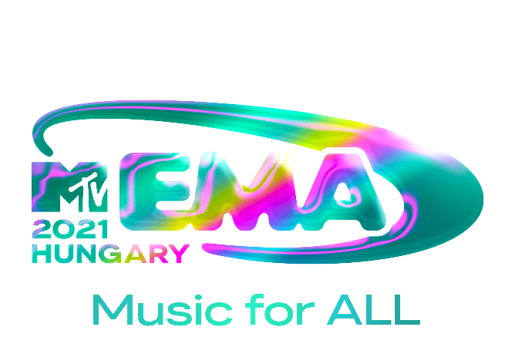

2021 MTV EMAs TO BROADCAST LIVE FROM HUNGARY
ON NOVEMBER 14TH WITH A GLOBAL CELEBRATION OF MUSIC

DOWNLOAD LOGO AND TEASER HERE
SOCIAL TAGS: #MTVEMA @MTVEMA

NEW YORK, NY—OCT. 19, 2021— The 2021 MTV EMAs will return live from the Papp László Budapest Sportaréna in Hungary, on November 14th with a global celebration of music for all audiences around the world. This unforgettable night will host performances and appearances by the world’s biggest stars.

“With a global footprint spanning 180 countries and countless cultures, the 2021 MTV EMAs will be an incredible moment for every member of our audience to come together to celebrate music and the power it has to transcend borders,” said Raffaele Annecchino, President and CEO of ViacomCBS Networks International. “After such a long period, I couldn’t be happier for the EMAs to land in Budapest for what’s sure to be an extraordinary night that will resonate globally.”

“Growing up gay in a working-class community, being able to see out role models on TV like Pedro Zamora from The Real World provided a literal lifeline for me and inspired a sense of hope and possibility to be the full person I was meant to be,” said Chris McCarthy, President and CEO, MTV Entertainment Group Worldwide. "That is why I am so proud to work at ViacomCBS, which has always championed equality for all, and why I’m so honored to stand in solidarity with my LGBTQ+ siblings as we celebrate the 2021 MTV EMAs from Hungary.”

“The MTV EMAs are our biggest night in global music, uniting fans from every corner of the world,” said Bruce Gillmer, President of Music, Music Talent, Programming & Events, ViacomCBS. “The 2021 EMAs will be an epic event as we return, live from Hungary, to light up the stage with incredible performances in celebration of all music fans and the artists they love.”

Show host, nominees, performers and presenters to be announced at a later date.

The 2021 MTV EMAs is sponsored by Adobe.

Fans can stay up-to-date with all things EMAs by following the show on Instagram, TikTok, Twitter and Facebook and follow the social conversation using #MTVEMA.

###

ABOUT THE 2021 MTV EMAs:
The MTV EMAs 2021 will broadcast across the globe on November 14th with a celebration of “Music for ALL.” One of the biggest global music awards shows of the year that celebrates the hottest artists from around the world, the MTV EMAs bring music fans a unique, multi-platform experience across MTV’s global network in 180 countries. Follow @MTVEMA on Facebook, Twitter, TikTok and Instagram, and join the conversation with #MTVEMA. Bruce Gillmer and Richard Godfrey are Executive Producers. Debbie Phillips and Chloe Mason are Producers.

PRESS CONTACTS:
Janice.Gatti@viacomcbs.com
Liza.Fefferman@viacomcbs.com
Christine.Woo@viacomcbs.com

